HSE Monthly Report – July 2026
Weyland Energy – all sites
Hannah Weber · 07 August 2026 · HSE-RPT-2026-07

1. Headlines
One restricted work case at Harrow Bay on 8 July: a technician's finger was caught between the pile handling tool and a guide (HSE-INC-2026-024, RIDDOR over-7-day report submitted). The rolling 12-month TRIR is 4.27; no further lost time injuries since March.
HSE-INC-2026-024 – investigation by Yusuf Demir, report due 29 July.

Indicator | July | YTD 2026 | 2025
Hours worked | 290,000 | 1,461,000 | 1,452,000
Lost time injuries | 0 | 1 | 2
Recordable injuries | 1 | 6 | 6
First aid cases | 8 | 38 | –
Near misses | 33 | 235 | 307
Safety observations | 344 | – | –
LTIFR rolling 12 months | 0.95 | – | 1.38
TRIR rolling 12 months | 4.27 | – | 4.13

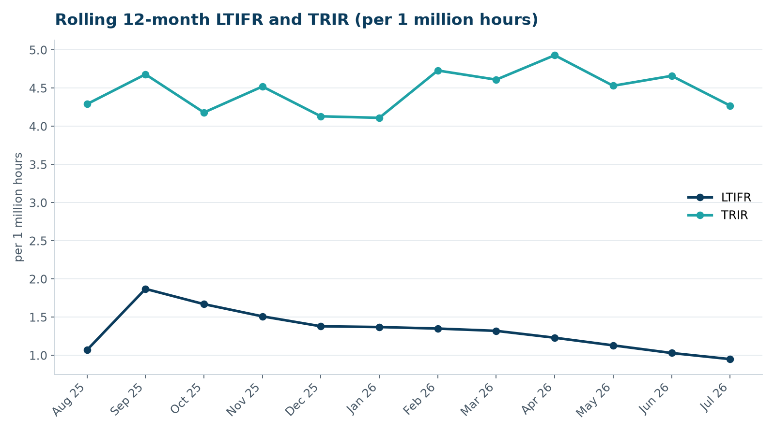

2. Hours by group
Group | Hours | Share
Weyland employees | 67,000 | 23 %
O&M contractors (operating assets) | 37,000 | 13 %
Harrow Bay contractors | 186,000 | 64 %

3. Leading indicators
- Toolbox talks delivered: 135
- Management safety walks: 13 (target 12)
- Inspections of lifting equipment: 71
- Open corrective actions older than 30 days: 6

4. Focus for next month
Contractor onboarding quality: induction checks for new crews on the Harrow Bay vessels.
Hannah Weber, HSE Manager

